**SIT725- Applied Software Engineering**

**Task 2.2P- Rest API and Express**

*Name: Joel Varghese*

*Student ID: s225566486*

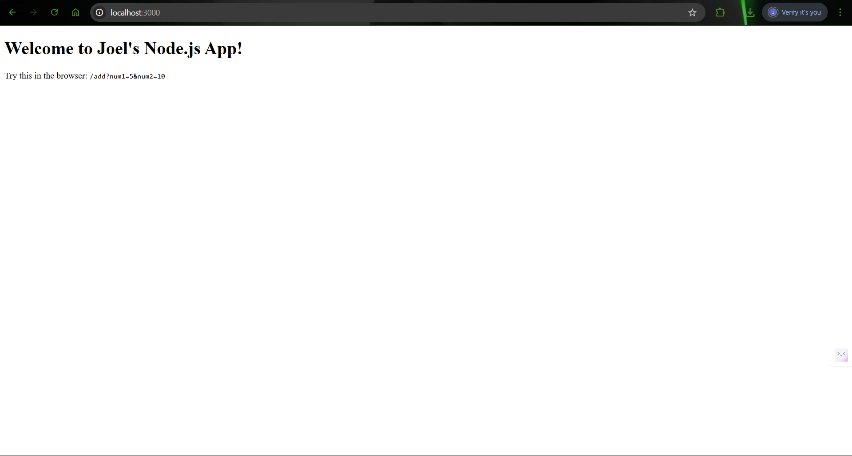

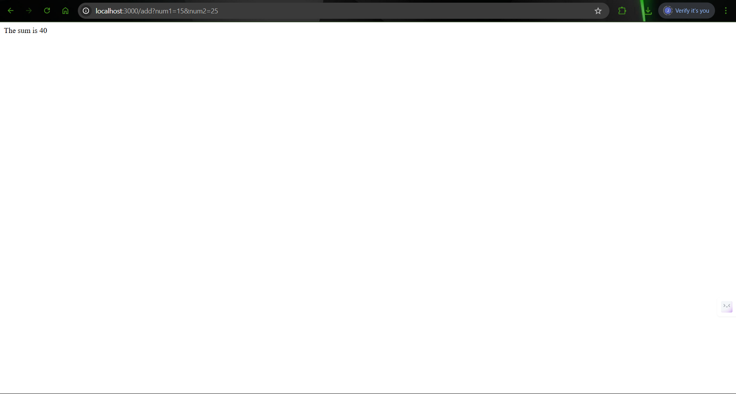

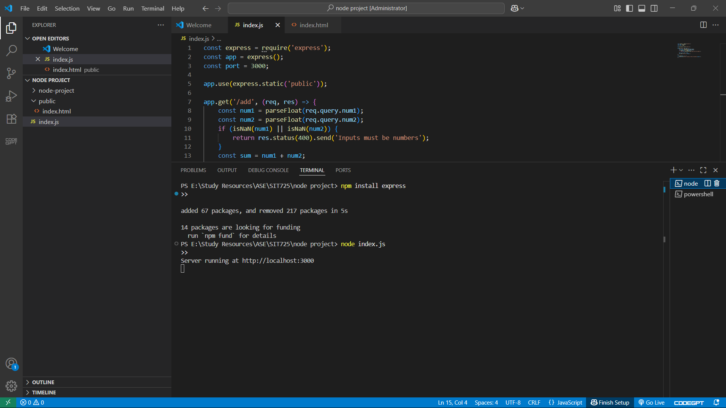

GitHub Repo Link: <https://github.com/JoelVarghese1706/SIT725>